Annexure A – Coding Challenge

1. Write a Python script that generates a star topology diagram (ASCII or graphical) given a number of hosts and a central switch. The script must print each host label, the switch name, and the connecting Cat6 UTP cable length.
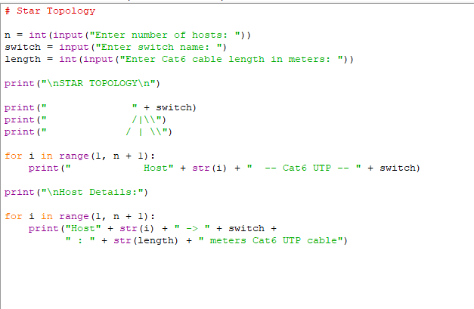

Output: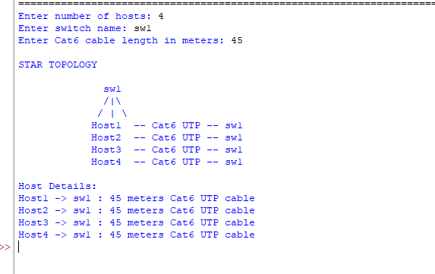

2.Code a function validate_segment(length_m) that returns True if the UTP segment is within IEEE 802.3 limits (≤100 m) and False with an error message otherwise. Include at least 3 test cases.

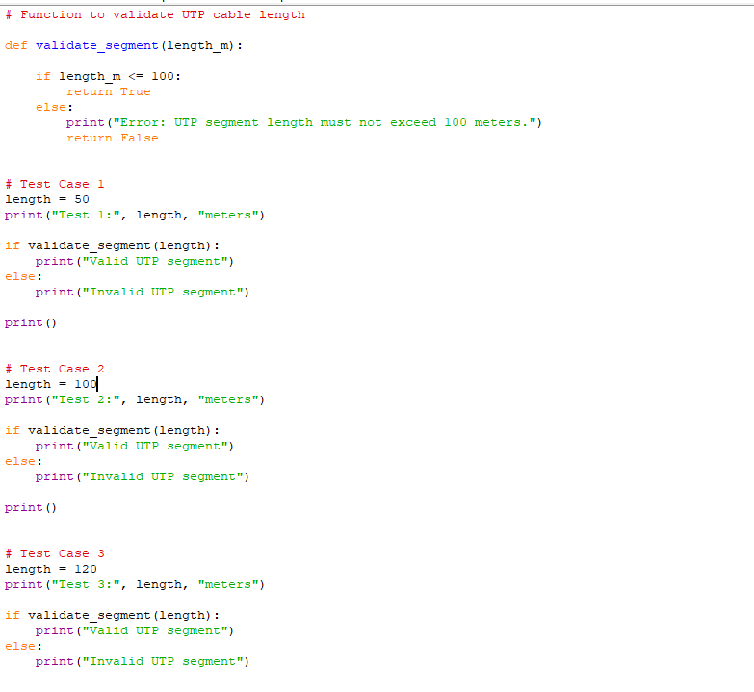
Output:
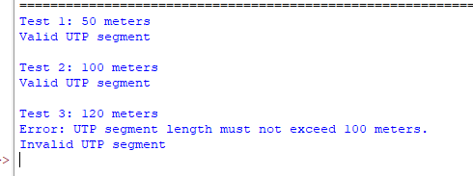

3.Write a script that simulates CSMA/CD on a star topology with 4 hosts. Log every collision detection event and the back-off interval to a file named csma_log.txt.
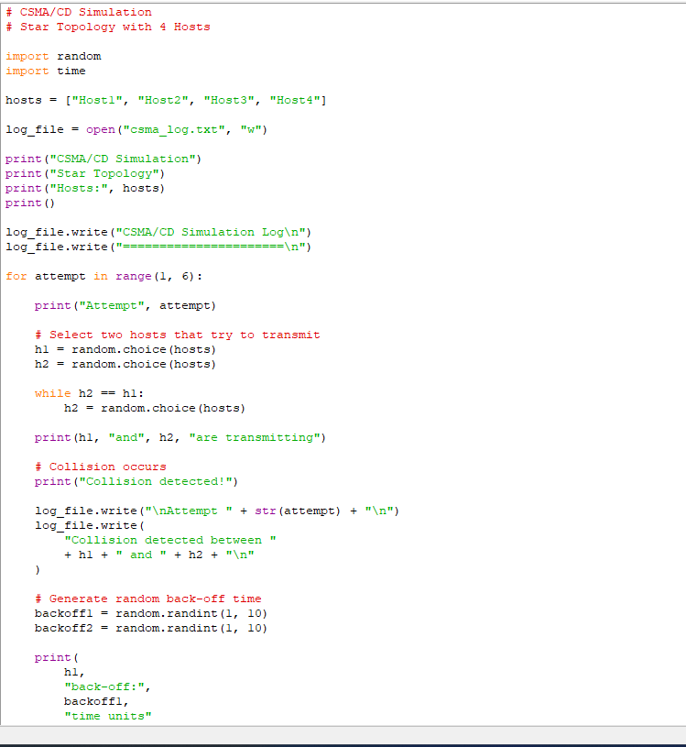

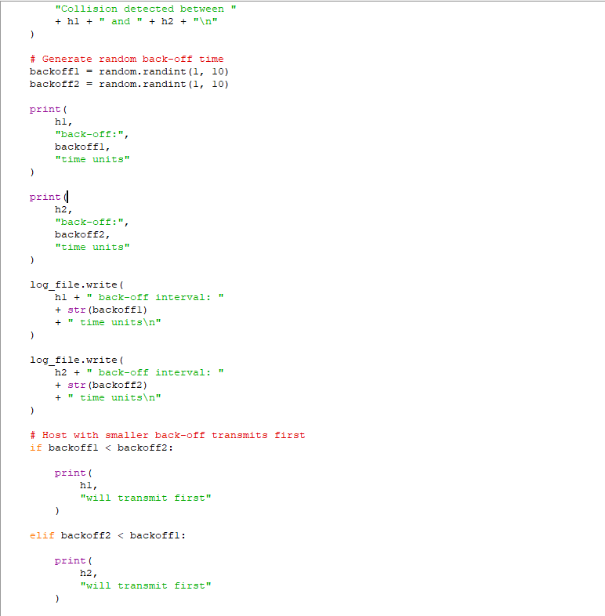

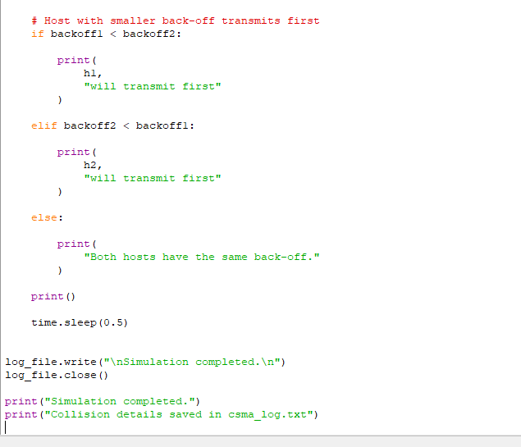

Output:

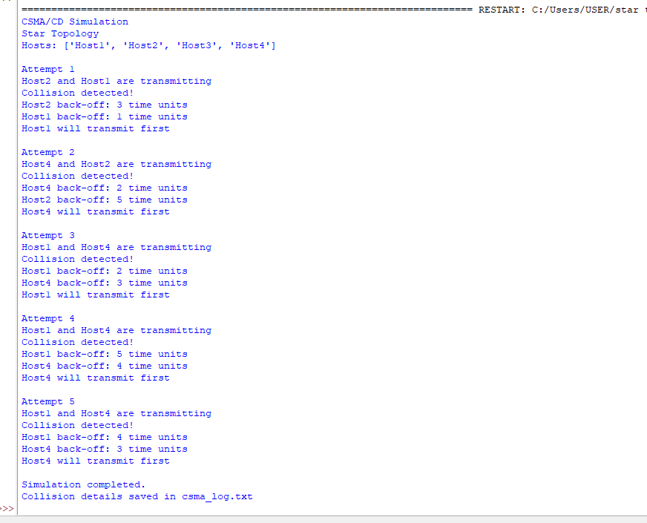

4. Using Python's socket library, write a client-server program that models two hosts communicating through a star switch. Demonstrate message forwarding by printing the switch's MAC address table after each frame transmission.
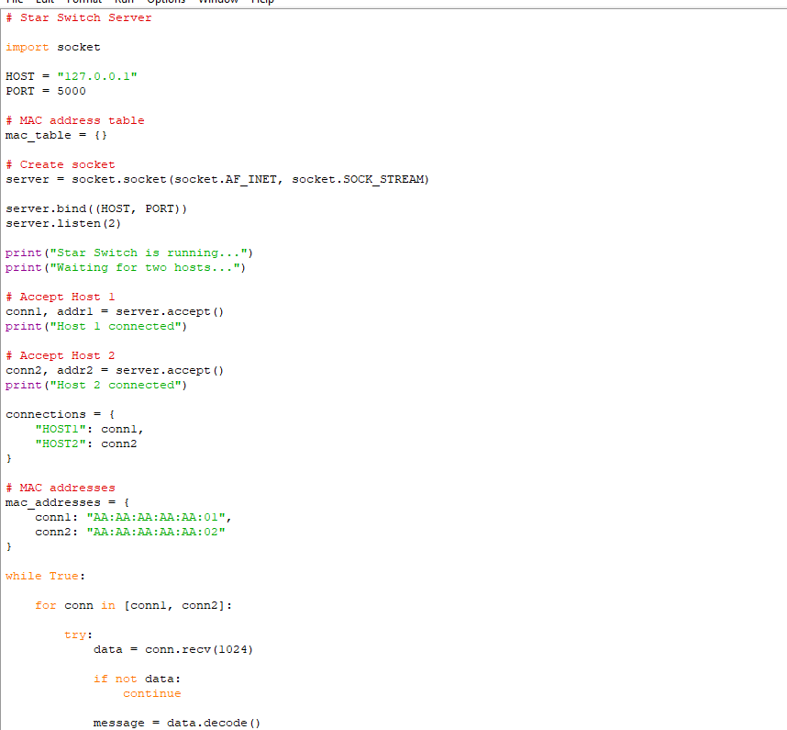

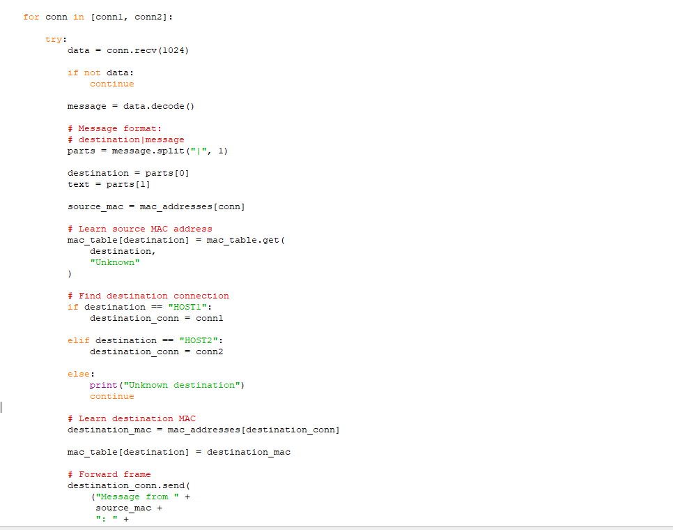
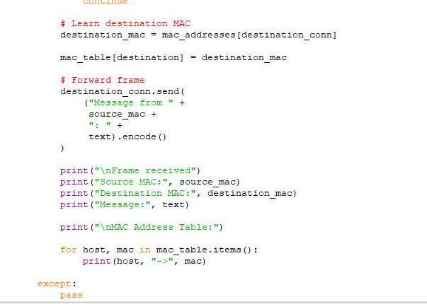

Output:
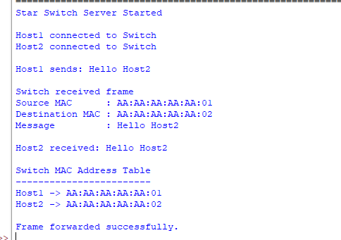
5. Create a class Star Switch with methods:
add_port(host_id)
remove_port(host_id)
forward(frame)
Broadcast must send a frame to all ports except the source and log each delivery.\
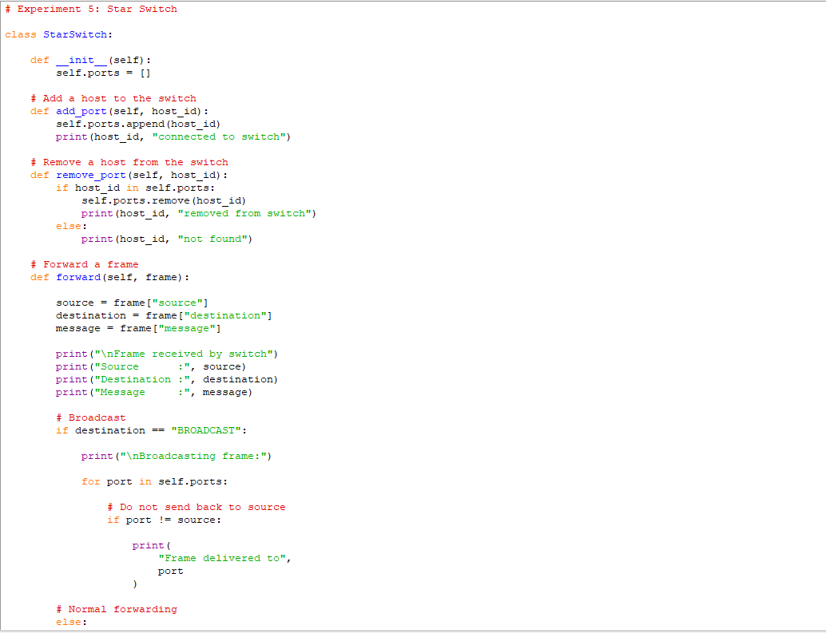
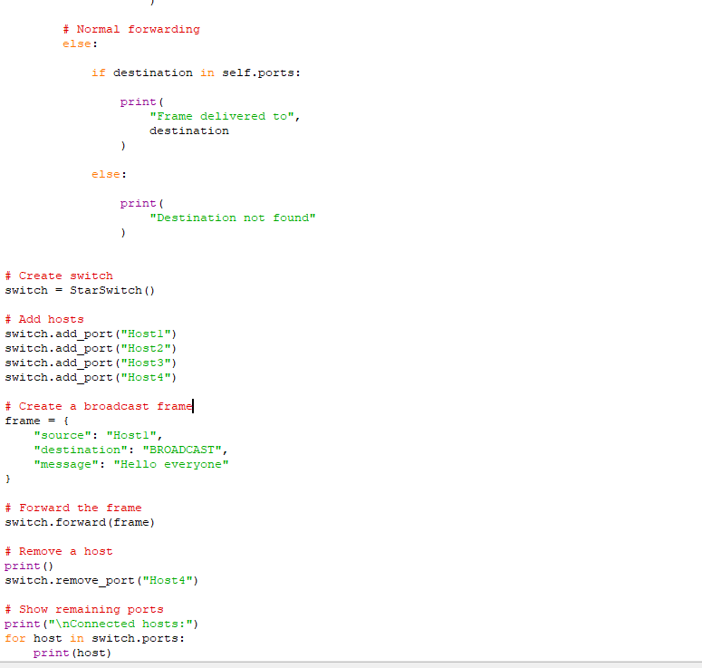

Output:
